Apply filters to SQL queries

Project description
My organization is looking to improve their security. It is my responsibility to ensure the system is safe, so I used SQL to filter through suspicious activity in different tasks.

Retrieve after hours failed login attempts
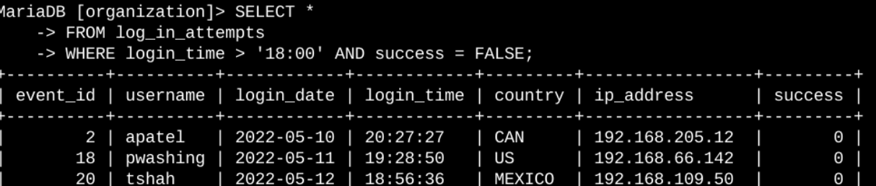
There was concern of a security breach that happened after 18:00. I investigated this potential security incident by selecting all data points (using the * symbol) from the log_in_attempts directory which had a login_time after 18:00 and were unsuccessful. After I sent the query, the response showed information (event ID, username, login date, login time, country, IP address) of users who tried to access the organization’s confidential information after hours and failed to login.

Retrieve login attempts on specific dates
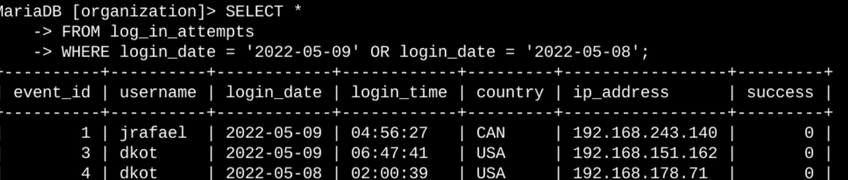
There was another concern of a security incident that occurred on either May 9, 2022 or May 8, 2022. I used the OR operator on the WHERE clause to only return login attempts that occurred on these dates.

Retrieve login attempts outside of Mexico
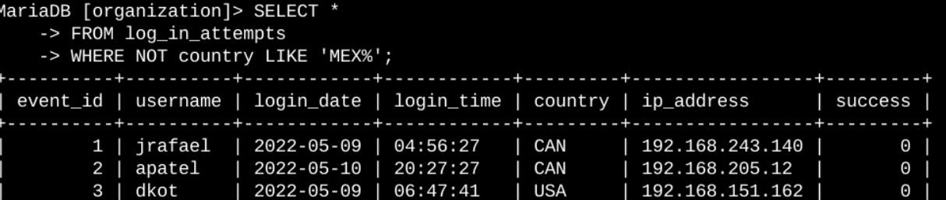
After investigating the previous concerns, there was an issue with the login attempts that occurred outside of Mexico. For the WHERE clause, I used the NOT operator to only return login attempts which were not from Mexico. I used ‘MEX%’ to include login attempts which listed the country as MEX or MEXICO, the % symbol indicating there could be more unspecified letters after ‘MEX’.

Retrieve employees in Marketing
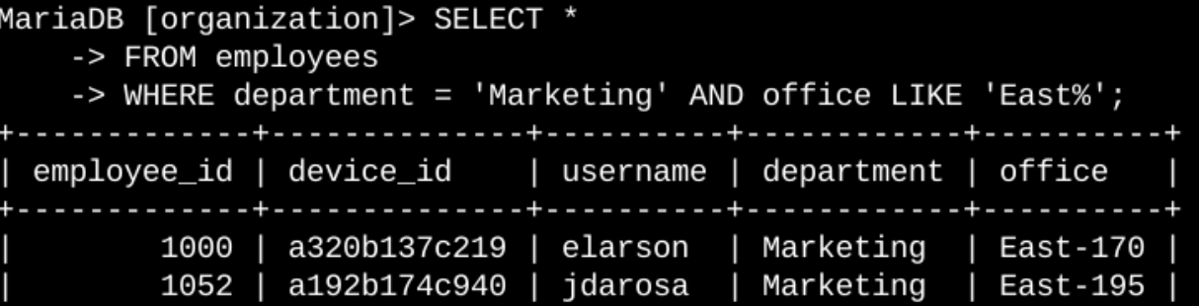
My team wanted to update computers for select employees in the Marketing department, specifically those in the East building. I sent a query to get all the employees in the Marketing department and in an office in the East building. In the WHERE clause, I assigned department to be equal to ‘Marketing’ and used the AND operator to also assign office to values that started with East, using LIKE.

Retrieve employees in Finance or Sales
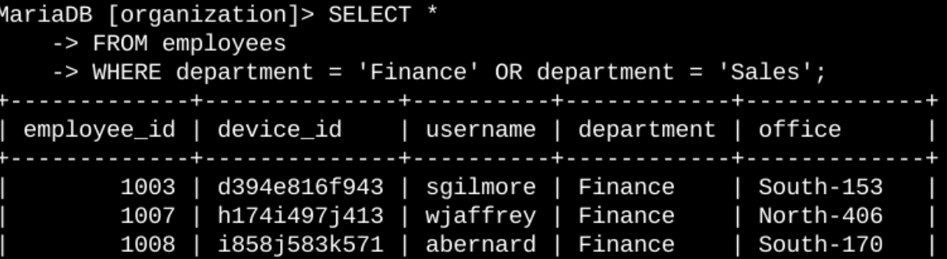
Some of the machines in the Finance and Sales departments also need to be updated. To ensure the employees in these departments are correctly determined, I queried the employees table to only return employees in the Finance or Sales departments. In the WHERE clause, I used the OR operator to return results of employees in either the Finance or Sales departments.

Retrieve all employees not in IT
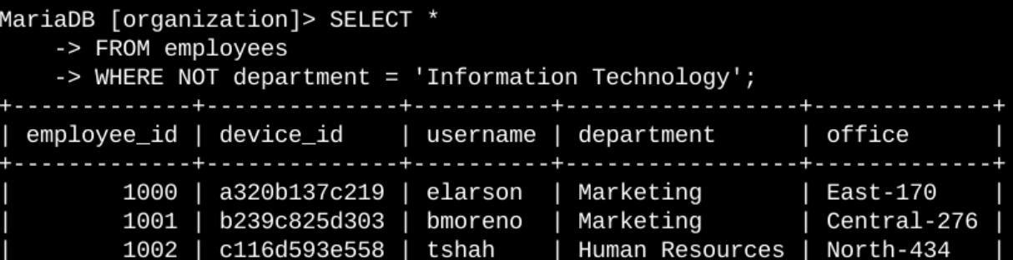
My team was interested in doing security updates for all employees except those in Information Technology (IT). To get the information of all the employees, I sent a query to return employees not in the IT department. To do this, I filtered the WHERE clause for the employees table by using the NOT operator to not include any employees which had a department of Information Technology.

Summary
By applying filters to SQL queries, I was able to identify the correct login attempts and employees for the organization’s desired tasks. Two different tables were used: the log_in_attempts table and the employees table. I also used the AND, NOT, and OR operators to filter through the specific information that was required.

